Contributor: Roxanne Doyen

**Pettoruti, Emilio**

Born: 1892 La Plata, Argentina; Died: 1971 Paris

Emilio Pettoruti was born in the city of La Plata, Argentina and the modern, geometric layout of this city would return in his art later on in his life. In 1913, Pettoruti received a scholarship from the government of Argentina and travelled to Italy. He studied Italian Art of the fourteenth century but also got to know avant-garde artists involved with **Futurism**. Pettoruti decided to expand his time in Europe and worked in different countries. In Paris, he became acquainted with artists such as **Pablo Picasso**, **Kees van Dongen** and **Juan Gris**, who had a major influence on Pettoruti’s artwork. He participated in an exhibition in Herberth Walden’s famous ‘Der Sturm’ Gallery in Berlin in 1923 and became a well-known modern artist. The avant-garde magazine *Martín Fierro* defined Pettoruti’s artwork (as they did the art of Pettoruti’s friend **Xul Solar**) as *Criollismo*, a term from literature, meaning a realist style to portray scenes and customs of the native country. Pettoruti’s style is a modern concept of harmony, order, geometric forms and a combination of science and the spiritual. Technique, light, colour and movement are the most important characteristics of his art.

Pettoruti did not want his art to be categorised and known as one specific style, because he constantly changed his style throughout his career. He is well-known for his paintings, but the artist also made theatre costumes, set designs, stained glass windows and mosaics. An example of his mosaic is *Meditazione* (1915) which shows a woman at the front of the mosaic and an abstract colourfield landscape in the background.

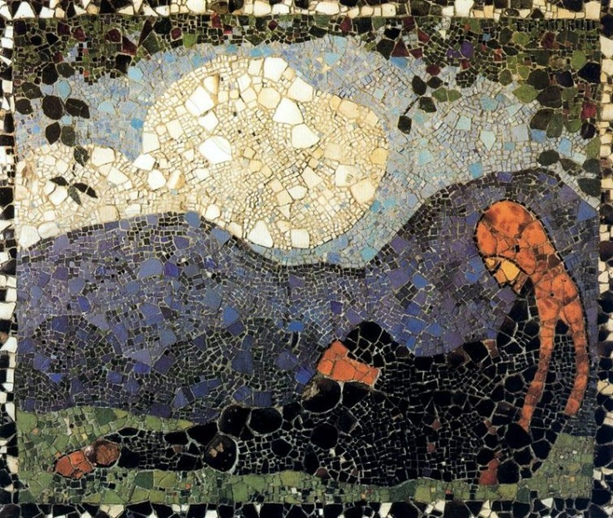

**Meditazione (1915)**

http://www.epdlp.com/cuadro.php?id=687

In 1924, Pettoruti decided to go back to Argentina due to family circumstances. He made a scandal with his exhibition at the Witcomb Gallery at *Calle Florida* in october 1924, because modernist art hadn’t been accepted yet in Argentina. The art collectors, mainly rich landowners, preferred paintings with gauchos, cattle and landscapes, in the reigning impressionist style. Pettoruti’s cubist paintings threatened the existing cultural order. However, some welcomed him with open arms. With this exhibition in 1924, Pettoruti tried to expand the freedom of expression, introduced aesthetic modernity in Argentina and opened doors for many Argentine painters.

Musicians are the main theme of Pettoruti’s paintings. He displayed musicians alone or in a group, always with their eyes hidden. The musicians were associated with the tango, representing Argentine culture, as his painting *Bailarines* (1918) shows. This painting also shows Pettoruti’s abstract style and his use of colourfields.Another theme in his paintings were harlequins, again with their eyes covered with masks, to show the human being as an anonymous, general person, not as an individual. Pettoruti also painted still-lifes, like *Sombras en la Ventana,* characterised by colourfields to flatten forms and light to enlarge this effect of flattening.

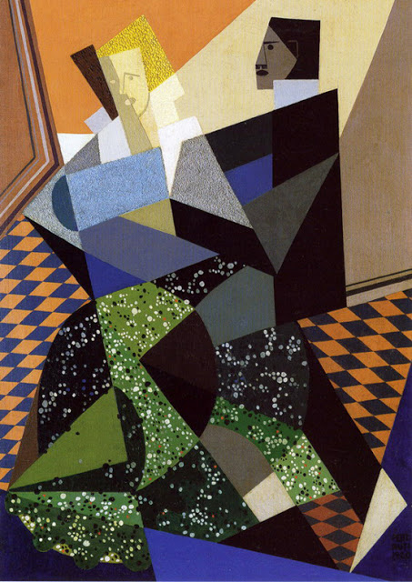

*Bailarines*, 1918, oil on canvas, 77 x 55 cm. [Museo Emilio Caraffa](http://www.museocaraffa.org.ar/)

In 1930 Pettoruti was named director of the Museo Provincial de Bellas Artes in his hometown La Plata. He changed the collection of the museum and added many modernist artworks. He remained director until 1947. In this period he had success as an artist as well, with his first solo-exhibition in the United States in 1942 and many other exhibitions in Europe as well.

In the 1950s Pettoruti painted almost only fully abstract paintings in which he used the communicative power of colour and the order of forms. His futuristic and cubist style and his use of colour and light lead him towards the creation of abstract art. An example of this style is the artists’ painting *Farfalla*, where he uses the colour yellow and simplistic forms in the center of the canvas.

In 1952 Pettoruti and his family decided to go back to Europe, because President Juan Perón’s government limited his freedom as a modern artist. Pettoruti settled down in Paris and wrote his autobiography *Un Pintor ante el Espejo* (A Painter before the Mirror) in 1968. Three years later he died in Paris.

**Further Reading:**

---- (2008). *Coleccion de Arte Amalia Lacroze de Fortabat*. Buenos Aires: Fundación de Amala Lacroze de Fortabat.

Giunta, A. (1999).  *Pintura Latinoamericana.* Buenos Aires: Ediciones Banco Velox.

Lucie-Smith, E. (2004) *Latin American Art of the 20th Century*. London: Thames & Hudson

Pettoruti, E. (2006) *A Painter before the Mirror.* Miami: Stockcero.

Sullivan, E.J. (2000) *Latin American Art in the Twentieth Century.* New York: Phaiden Press Inc.

[www.pettoruti.com](http://www.pettoruti.com)

**List of Works:**

Emilio Pettoruti, *Meditazione*, 1915, mosaic, 78 x 91 cm, Colección Fundación Pettoruti, Argentina.

Emilio Pettoruti, *Bailarines*, 1920, oil on canvas, 77 x 55 cm, Museo Emilio Caraffa, Córdoba Argentina.

Emilio Pettoruti, *Sombras en la ventana,* 1925, oil on wood, 41,5 x 26 cm, Museo Nacional de Bellas Artes, Buenos Aires.

Emilio Pettoruti, *Arlequin*, 1928, oil on canvas, 114 x 70 cm, Museo Nacional de Bellas Artes, Buenos Aires.

Emilio Pettoruti, *Vino Rosso*, 1940, oil on canvas, 65 x 80 cm, Museo Nacional de Bellas Artes Buenos Aires.

Emilio Pettoruti, *Sol Argentino*, 1941, oil on canvas, 98 x 67 cm, Museo Nacional de Bellas Artes, Buenos Aires.

Emilio Pettoruti, *Winter in Paris,* 1955, oil on canvas, 210 x 135 cm, Museo Nacional de Bellas Artes, Buenos Aires.

Emilio Pettoruti, *Farfalla,* 1961, oil on canvas, 161,5 x 114 cm, Museo Nacional de Bellas Artes, Buenos Aires.